Craigentinny Allotments Wildlife Report 1 (August 4th 2021)

Since the start of lockdown seventeen months ago we have been collecting wildlife sightings and I have been summarising them on a monthly basis (and also for the year through from March 2020 to February 2021).

In all, I reckon that not far short of half of our number have sent me something that has appeared in one of the reports. And quite a few people have commented both on how interesting it has been and how much we have all learned, and on what a brilliant idea it was to set out to do it during lockdown (thanks to John McKinley).

In the last few months, as lockdown has eased, I have been receiving fewer reports, not least because many of us have been less often on the site. And we are now entering the time of year when much wildlife activity quietens down.

So, in discussion with various of our number, it has been suggested that, rather than seeking to continue to produce comprehensive monthly reports, we should move to a periodic ‘Wildlife News’, coming out at varying intervals, and particularly focusing on new or less routine species. Now that the website is up and running, it is hoped that Wildlife News items will be added as they emerge. This will hopefully also include more photos, and maybe slightly extended comments on interesting happenings or species.

So, what follows is a test run.

July is always a quieter month for birds on our site, as also elsewhere other than on the coast, where autumn migration has already begun. With us, most nesting has finished, and many of our residents are moulting their feathers and so hiding away as much as possible. Also, because this is one of the months when the largest proportion of most plots are in intensive cultivation (often in cages or netting), there are rather fewer opportunities for birds to feed on weed seeds, or on soil or plant-living animals.

But quite a few of our usual residents and frequent visitors have still been around: adult Blackbirds of both sexes and at least one that fledged several weeks ago, Woodpigeons, Carrion Crows, at least one Dunnock, Goldfinches, at least one Robin, overflying Herring Gulls, and the start of the regular autumn build-up of House Sparrows which, while increasingly rare in much of the city, are still flourishing in most of the suburbs and certainly on our site. Ten Oystercatchers flew overhead one day, and a nice find by Rachel was two Blackcaps in the laburnum by the gate.

Mammals have been very much as usual. Probably because, as is quite usual, the family has now dispersed, we seem now to have only one resident Fox, but quite tame, Woodmice are clearly around, devouring peas and other seeding plants. Also, just recently reported, we again have Rats (this is maybe slightly surprising because earlier in the year the Fox seemed to be specialising on them – and this may be an argument to avoid poison for a wee while). I’m not sure whether any Grey Squirrels are still around.

White butterflies (I think probably only Small Whites) are still to be seen on most days. Otherwise, we saw a Small Tortoiseshell early in the month and Norma had a Speckled Wood. But, in general, butterfly numbers do seem to be sadly reduced from the past. Forty years ago, almost any Buddleia in flower in southern Scotland would have been covered in butterflies, but nowadays there seem to be hardly any on the bushes on our site or elsewhere. Part at least of the cause may be that climate change has disconnected the peak flowering time for buddleias from the peak flying time for butterflies.

However, it is now worth keeping an eye open for moths. Many are very small and difficult to identify and most only fly in the evenings or at night. But several day-flying species are around at present. One day we found a nice Garden Tiger Moth partially hidden in our rhubarb (see photo – when in flight they show a lot of red and white on their wings).

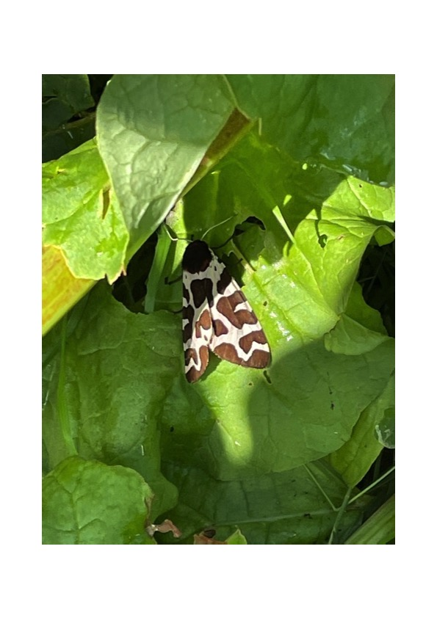

And Noma on her plot had a good find of a black and red Cinnabar Moth (whose yellow and black striped caterpillars devour yellow Ragwort plants)

Otherwise, there are still lots of bumblebees (now I think mainly White-bottomed) a few Wasps, and my impression is fewer Hoverflies than last year. And, very occasionally, Ladybirds.

Frogs have been reported from several plots, including one that I photographed, also in our rhubarb, which was about an inch long – seems a bit big for one of this year’s though I guess some of our tadpoles may have left the water at least a month ago.

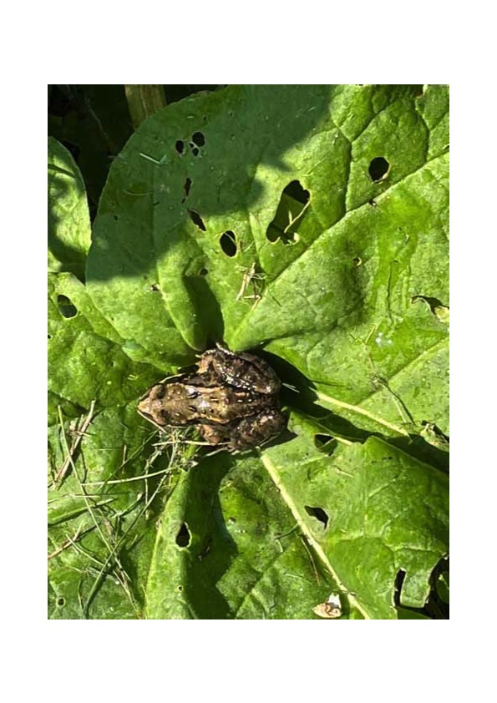

And still, as ever, lots of soil-living animals. There are quite a few black ants’ nests around. but I’ve not seen any of the small yellow ones this year (they are the ants that over the summer create mounds which can be up to about six inches high – but, unlike the black ones which make nests under slabs and logs, they mainly live in uncultivated dry grassland and most of our site is now too cultivated for them).

As for animals that live underground, earth worms continue to be scarce on our plot at least, but it’s a while now since anyone reported New Zealand Flatworms, which might be encouraging lack of news. What there are are quite a few centipedes, especially the wriggly thin yellow ones (I think probably Western Yellows) as photographed by Fiona.

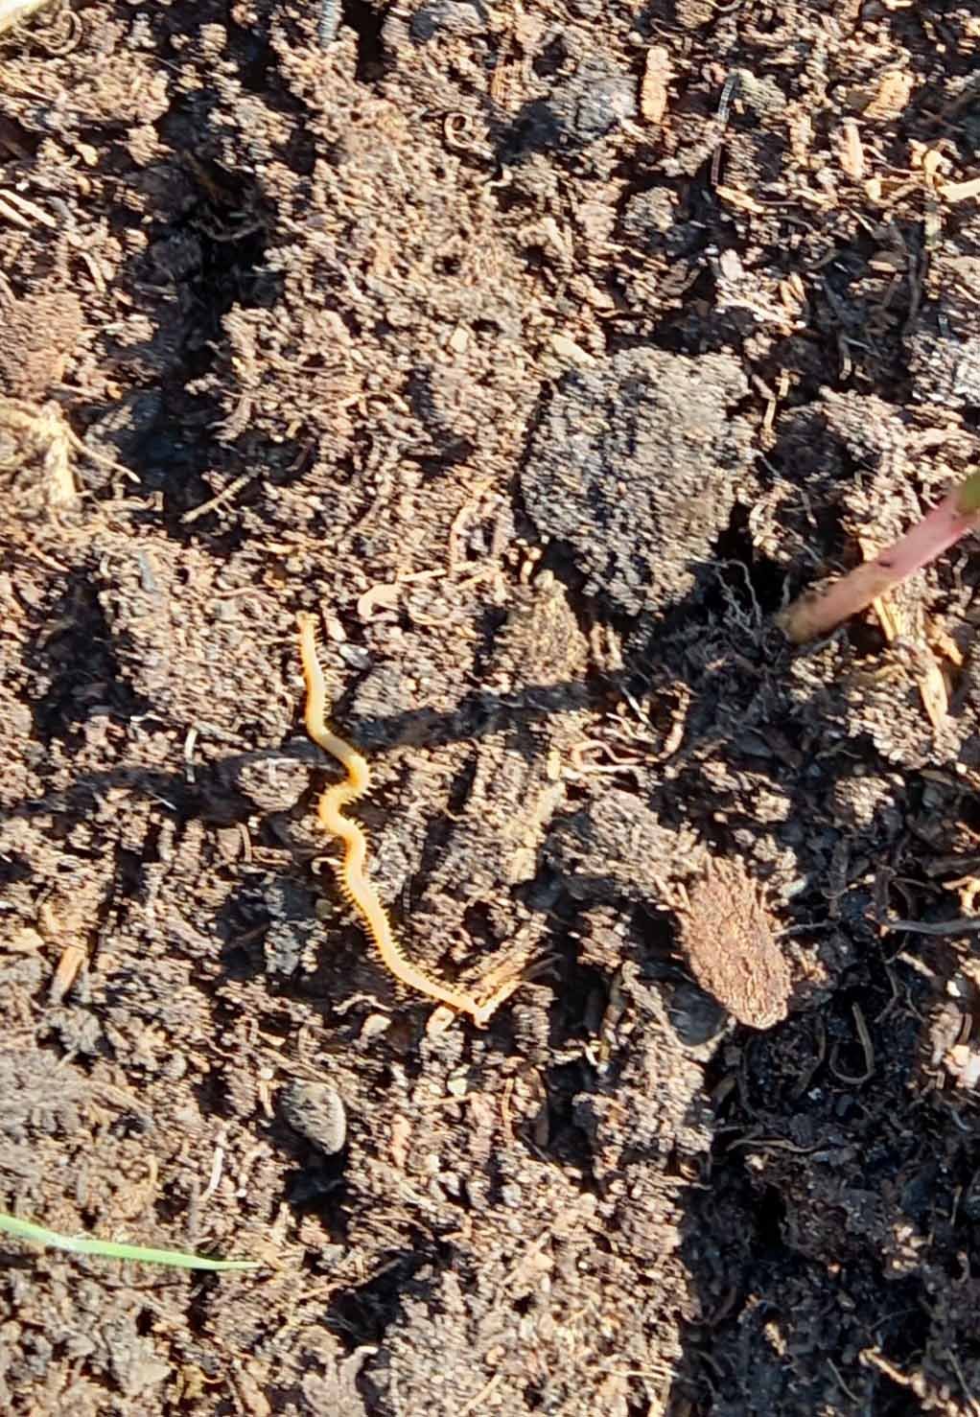

And that’s it for now. Do let me know what you think about this new way of presenting material, and, if you want it to continue, keep sightings coming in.

Mike

